YESHIVA BAIS YITZCHOK
1413 – 45TH STREET
BROOKLYN, NY 11219
718 854-0800 FAX 718 532-2720

October 27, 2025

To Whom It May Concern:

Please be advised that Mr. & Mrs. Alec Dorfman residing at 1179 51st Street, Brooklyn, NY 11219 are parents of the following child attending our school:

Solomon Dorfman D.O.B. 11/29/2019

All courtesies extended to the above shall be greatly appreciated.

Sincerely,
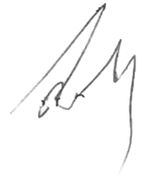

Sara Sperier
Secretary

